4.10: a) The acceleration is 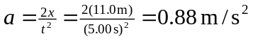. The mass is then 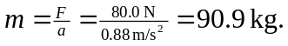
b) The speed at the end of the first 5.00 seconds is 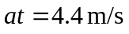, and the block on the frictionless surface will continue to move at this speed, so it will move another 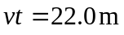 in the next 5.00 s.

